DDOS ATTACK DETECTION AND MITIGATION (REAL-TIME DDOS DETECTION AND ADAPTIVE MITIGATION FRAMEWORK USING MACHINE LEARNING)
Conclusion, Future Scope and References
Department of Computer Science and Engineering, [COLLEGE NAME]
Batch C15 (CSE-C) · Academic year [ACADEMIC YEAR]
Table 1: Project team
S.No. | Student name | Roll number
1 | Mallela Pallavi | 23K91A05E3
2 | Kattoju Durgabhavani | 24K95A0514
3 | Nimmala Rakshitha | 23K91A05H3
4 | Prodhatoor Shashi Preetham | 23K91A05K0

Project guide: V Meenakshi
Chapter and section numbers quoted in the text (for example Chapter 8 or Section 6.2) refer to the full project report, 17.Final Document. Figures and tables in this document are numbered from 1.

1. CONCLUSION

1.1 Summary of the work
The batch asked for a framework that detects DDoS traffic in real time and applies adaptive mitigation without blocking legitimate users. The project delivered SentinelFlow: Scapy or simulated traffic windows, ten flow features, a 200-tree Random Forest, an explainable distributed-risk and severity layer, temporary quarantine with automatic recovery, a SQLite history, twelve REST endpoints and a nine-page React console, backed by 95 passing tests and 25 passing smoke checks. It follows the base paper [1] and adds the closed detection-to-mitigation loop that the paper leaves as future work.
In the documentation phase the product was evaluated more strictly than it had been built. The shipped model, trained on a synthetic fallback, scores 99.71 % on its own split but 71.8 % on 225,745 real CICIDS2017 DDoS-day flows; the same forest retrained on real flows reaches 99.94 ± 0.01 %. The two layers must be read separately: the engineering (pipeline, API, console, tests) works as designed; the shipped model's headline figure does not describe real traffic.

1.2 Objectives achieved and not achieved
Table 2: Batch objectives against the outcome
Objective | Status | Evidence
1. Acquire a benchmark dataset and extract flow features | Partly | The training script reads CICIDS2017 CSVs from data/raw and otherwise builds a labelled synthetic fallback, which is what shipped. During documentation the real Friday-DDoS file (225,745 flows) was obtained and mapped with the product's own preprocessing; the shipped model was not retrained on it.
2. Capture live traffic and compute the same features in real time | Implemented, not verified live | Scapy capture, rolling windows and the aggregator use the training schema. Npcap is not installed on the test machine, so only the error path was exercised; the simulator drives the identical pipeline.
3. Train a classifier to separate DDoS from legitimate traffic | Achieved after retraining | Shipped synthetic-trained forest: 99.71 % on its own split but 71.8 % on real flows. Same forest retrained on real flows: 99.94 ± 0.01 % over five seeds.
4. Adaptive mitigation that rate-limits or blocks sources | Partly | High and Critical windows quarantine the top three non-protected sources for 40 s (80 s for Critical) with automatic recovery, inside the application. Rate limiting is only recommended; the OS firewall is never touched.
5. Dashboard of live traffic, detections and mitigation | Achieved | Nine-page React console plus the original Flask dashboard; polling every 2 s; every screen captured with data.
6. Evaluate accuracy, false-positive rate and time from detection to mitigation | Achieved for offline evaluation | Accuracy and false-positive rate on a synthetic split, on real flows and through the window pipeline at three window lengths; decision latency median 217 ms on a saturated host. No real attack timeline was measured.

The statuses are strict. 'Partly' means a simpler version of the step exists; 'Implemented, not verified live' means the code exists and its failure path was tested but live capture was not possible; nothing is claimed beyond the table.

1.3 Key findings
1. The synthetic-trained model does not transfer. The shipped forest scores 99.71 % accuracy and 0.04 % false positives on its own 4,800-row split, but on the 225,745 real CICIDS2017 DDoS-day flows it scores 71.8 % accuracy, 63.4 % recall and 17.2 % false positives (ROC-AUC 86.1 %: the ranking is informative, the 0.5 threshold is not).
2. The same forest trained on real flows is accurate. With identical features and hyper-parameters, five seeds give 99.94 ± 0.01 % accuracy and 0.058 ± 0.006 % false positives; a chronological block split (first 70 % train, last 30 % test) gives 99.74 %. This is the same order as the 100 % reported by the base paper [1], on different data and with a different protocol.
3. Simple tree models are enough on this data. On the same real split a decision tree (99.94 %), the 200-tree forest (99.94 %) and histogram gradient boosting (99.95 %) are indistinguishable; logistic regression reaches 98.59 % and Gaussian Naive Bayes only 72.9 %. The forest takes 6.9 s to train and its file is 1.24 MB.
4. Packet and byte counts carry the signal. Four count-and-byte features alone give 99.91 %; sent-direction features alone 99.89 %; received-direction features alone fall to 95.8 % with 9.6 % false positives. The rate features add nothing on flows.
5. Window length decides the false-alarm rate. The model was calibrated on 10-second windows. On 4,000 simulator windows the forest label alone raises false positives on benign windows of 46.0 % at 2 s, 13.6 % at 5 s and 0.0 % at 10 s (the last figure is flattering, because the simulator generated the training windows).
6. The severity layer removes most false alarms. Acting only on High or Critical severity cuts those false positives to 6.77 % at 2 s and 0.27 % at 5 s while 100 % of attack windows still reach High or Critical at both lengths; at 10 s recall is 96.96 % because 44 weaker attack windows stay at Medium. The distributed-risk score alone is precise but weak: at threshold 0.7 it has 100 % precision and only 31.9 %, 19.2 % and 9.0 % recall at 2, 5 and 10 s.
7. Flow-scale and window-scale rows are different populations. A forest trained on real flows only labels every simulator window Benign (recall 0 at all three window lengths) although its ROC-AUC on those windows is 100.0 %. The product's recipe of adding 6,000 window rows fixes this on windows (100.0 % on fresh windows from the same generator) while keeping 99.93 % on the mixed test split.
8. Decision latency is small next to the window. On a host whose CPU was saturated by other jobs, the time from the finished feature vector to the mitigation decision had a median of 217 ms (95th percentile 489 ms), dominated by forest inference: the saved forest has n_jobs=-1, which costs 313 ms per single window against 33 ms with n_jobs=1. The real delay to a decision is the window length, 10 s by default.
9. The software is tested. 95 pytest tests and 25 smoke checks pass; 25 of 25 malformed-input probes were handled as intended; the REST endpoints answer in a median of 3 to 36 ms on 127.0.0.1.
Figure 9.1 and Figure 9.2 summarise the two findings that most change how the system should be read: the gap between synthetic and real data, and the effect of window length with and without the severity layer.
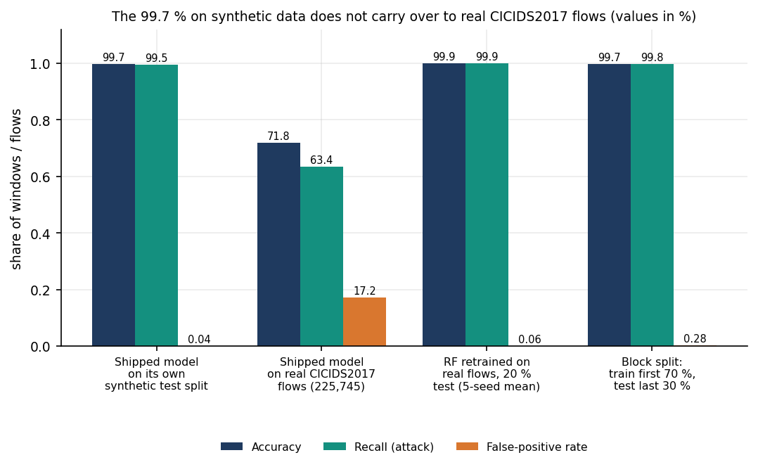
Figure 1: Accuracy, recall and false-positive rate: shipped model on synthetic data and on real flows, and the forest retrained on real flows.
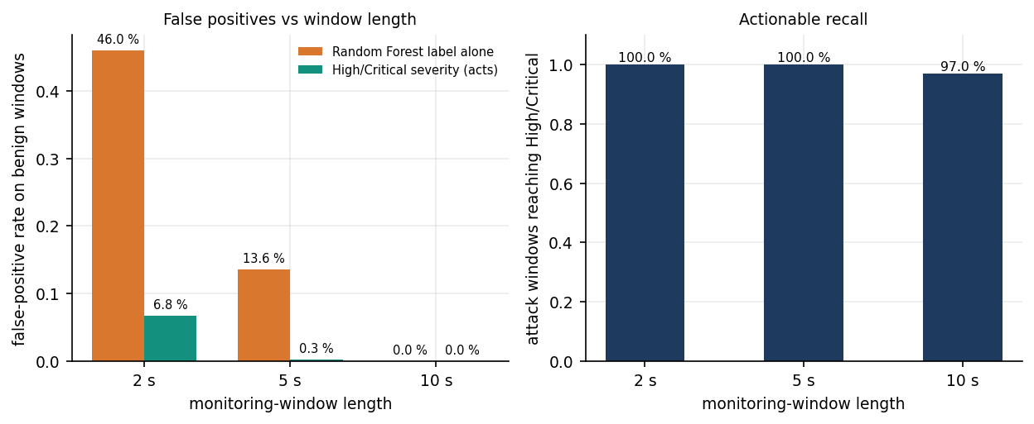
Figure 2: False-positive rate on benign windows and attack recall at 2, 5 and 10 s windows.

1.4 Practical applications
SentinelFlow is a teaching and prototyping tool for network-security courses and small labs: it shows the whole path from packets to a verdict, an explanation and a reversible action; it provides a safe simulator for demonstrations; and it is a test bed for the evaluation mistakes the report exposes (synthetic data, window-length calibration, forests saved with a parallel setting). It is not a replacement for a firewall, a scrubbing service or a commercial intrusion-prevention system, and it must be retrained on real captures before any operational use.

1.5 Known limitations
1. Synthetic training data in the shipped model. CICIDS2017 was unreachable when the product was built, so the shipped forest was trained on 24,000 rows of a labelled synthetic fallback (flows) plus simulator windows. Its 99.71 % is a figure about that data, not about real traffic; on real flows it scores 71.8 %.
2. Real-data result covers one attack day. The retrained forest was tested on one CICIDS2017 file (Friday afternoon, 225,745 flows). Random 80/20 splits of flows from one capture overlap in time, the block split (99.74 %) is the stricter figure, and CICIDS2017 labels are known to contain errors [9]. Other attack types and other datasets were not tested.
3. Ten features describe a flow, not an attack. The schema is five counters per direction. On the real flows the model leans on packet and byte counts and sizes; it has no TCP-flag, port, inter-arrival or entropy information, so attacks that look like ordinary volume are out of reach.
4. Window length sensitivity. The calibration is for 10 s windows. The Simulation Mode default is 5 s and the screenshots were captured at 2 s, where the forest label alone has 46.0 % false positives on benign windows; only the severity layer keeps the acted-on rate at 6.77 %.
5. Mitigation is an application-level denylist. Quarantine adds an address to a list inside SentinelFlow for 40 s (80 s for Critical). apply_os_firewall_block() is a stub that returns applied: false; no packet is dropped anywhere. Rate limiting is only recommended.
6. Live capture was not run end to end. Scapy capture needs Npcap and administrator rights. Neither is available on the test machine; the start request returns 200, the status endpoint reports the real driver error and the mode returns to stopped. All performance numbers come from real flow files and from the simulator.
7. Simulator windows are not real attacks. Flood, carpet-bombing and slow-style windows are generated in software with fixed address pools and sizes. The forest was trained on windows from the same generator, so near-perfect scores on fresh simulator windows say little.
8. Landing page headline. The landing page shows 99.71 % F1 without a caveat; only the Model page carries the 'synthetic training data' warning.
9. Inference cost of the saved forest. The forest was saved with n_jobs=-1, so classifying one window costs a median of 313 ms on the loaded test host against 33 ms with one worker.
10. No authentication on the REST API; unvalidated interface name. The API binds to 127.0.0.1 only and the React login is a browser-side demo gate. The interface setting accepts a 5,000-character string. 25 of 25 other probes behaved as intended.

2. FUTURE SCOPE

2.1 Improvements to the existing system
The improvements below follow directly from the measurements; the first three would change the headline results.
1. Retrain on real data and ship that model. Place the CICIDS2017 CSVs in data/raw (the training script already uses them) and add CIC-DDoS2023 and an SDN flow dataset as the base paper does, so that the shipped forest is not synthetic. The real-flow result (99.94 ± 0.01 %) shows the pipeline is ready; what is missing is the artefact and a split that respects time.
2. Calibrate for the window length. Train with window rows built at the configured length (or at several lengths), store the length in the model metadata and refuse or warn when the console runs with a different one; at 2 s the forest label alone gave 46.0 % false positives on benign windows.
3. Fix the inference setting. Save the forest with n_jobs=1 (or set it at load time): single-window inference falls from 313 ms to 33 ms on the loaded test host, which removes the largest part of the decision time.
4. Make the landing page honest. Show the synthetic warning wherever the headline metric appears, and show the real-data figures once the model is retrained.
5. Persist settings and validate every field. Use the existing settings table for window length and quarantine duration, and reject over-long interface values.
6. Learn the severity thresholds. Replace the hand-set weights and cut-offs by values tuned on labelled windows, keeping the factor list so that every verdict stays explainable.

2.2 Additional features
• Richer features: entropy of destination and source addresses per window, TCP flag rates (SYN, ACK, RST), protocol shares, inter-arrival statistics and per-destination packet counts for a sharper carpet-bombing signal. The aggregator already collects protocol and top-destination context that the model does not yet use.
• Multi-class typing: classify SYN flood, UDP flood, HTTP flood and carpet bombing so that the recommended action can differ (the base paper lists multi-class detection as future work as well).
• Ensembles and feature selection from the base paper [1]: voting ensembles and Banzhaf-index selection become useful once the feature set is larger than ten.
• Online learning: update the model from confirmed windows, with a guard against an attacker poisoning the training stream.
• Notifications and export: e-mail or chat alerts on High and Critical windows and a CSV or PDF export of the detection history.
• Authentication and roles: replace the browser-side demo gate by server-side accounts and protect the REST API before it is bound to anything other than 127.0.0.1.

2.3 Scalability and deployment
• Live testing: install Npcap, run SentinelFlow as administrator against a lab network with a traffic generator under the supervision of the department, and measure time from the first attack packet to the first quarantine.
• OS-level enforcement with explicit opt-in: implement apply_os_firewall_block() for Windows Firewall or iptables behind a confirmation setting, a protected-address list and an automatic rollback, so that the safe default stays unchanged.
• SDN integration: feed flow statistics from an SDN controller instead of Scapy windows and install throttling or blackhole rules through the controller, as the base paper [1] proposes for a sidecar.
• Deployment: package the API and the console in the existing Docker image with a production server, add rotation of the SQLite history or a server database, and move polling to server-sent events.
• Scale: measure capture throughput at line rate, move aggregation to a compiled or kernel-assisted capture path, and run several sensors that report to one console.

2.4 Further research
• Transfer between datasets and window lengths: the flow-to-window gap measured here suggests studying domain adaptation between flow-level training data and window-level sensors, and testing on CIC-DDoS2023 and SDN data as in the base paper.
• Retrieval and language-model detection: the carpet-bombing paper [6] avoids retraining by retrieval; comparing its accuracy, cost (about 2 s per request) and robustness with a calibrated forest on the same traffic is an open question.
• Dataset quality: repeat the evaluation on a relabelled CICIDS2017 [9] and on captures made by the team.
• False-positive cost: quantify the harm of quarantining a legitimate source, for example by replaying benign traffic with known senders and counting wrongly quarantined addresses.
• Adversarial behaviour: test evasion by low-rate or slowly ramping floods and by spoofed sources, against which a source-based quarantine is weak (see the taxonomy of Mirkovic and Reiher [11]).

3. REFERENCES
[1] M. M. Trigui, M. S. Islam, M. D. Gambo, M. S. Alam and T. Helmy, "Resource-aware ensemble framework for DDoS detection in SDN via novel game-theoretic feature selection," IEEE Access, vol. 14, pp. 1666-1676, 2026, doi: 10.1109/ACCESS.2025.3618519.
[2] S. Areef and G. Vijayasri, "DDoS attack detection and mitigation," Int. J. Eng. Sci. Adv. Technol., vol. 26, no. 4, pp. 115-120, 2026, doi: 10.64771/ijesat.2026.v26.i6.3198 (record as given by Crossref; abstract not available).
[3] N. Raghavendran and Y. H. Robinson, "IoT-based WISNE-SDN detection and DDoS attack mitigation using machine learning techniques," PeerJ Comput. Sci., vol. 12, Art. no. e3572, Feb. 2026, doi: 10.7717/peerj-cs.3572.
[4] M. Jadric and S. Mladenovic, "DDoS attack detection and mitigation using double deep Q-networks," in Proc. 2025 Int. Conf. Software, Telecommun. Comput. Netw. (SoftCOM), Split, Croatia, Sep. 2025, pp. 1-6, doi: 10.23919/SoftCOM66362.2025.11197364.
[5] "AI-driven DDoS attack detection and mitigation in SDN," IJARCCE, vol. 14, no. 4, 2025, doi: 10.17148/IJARCCE.2025.144107 (authors not listed in Crossref; abstract not available).
[6] M. N. Swileh, S. Zhang and K. Lei, "Intelligent detection and mitigation of carpet-bombing DDoS attacks in SDN using retrieval-augmented generation and large language models," arXiv:2605.26307, May 2026.
[7] M. A. Rahman, "Detection of distributed denial of service attacks based on machine learning algorithms," arXiv:2502.00975, Feb. 2025.
[8] I. Sharafaldin, A. Habibi Lashkari and A. A. Ghorbani, "Toward generating a new intrusion detection dataset and intrusion traffic characterization," in Proc. 4th Int. Conf. Inf. Syst. Secur. Privacy (ICISSP), Funchal, Portugal, Jan. 2018, pp. 108-116, doi: 10.5220/0006639801080116.
[9] G. Engelen, V. Rimmer and W. Joosen, "Troubleshooting an intrusion detection dataset: The CICIDS2017 case study," in Proc. 2021 IEEE Secur. Privacy Workshops (SPW), May 2021, pp. 7-12, doi: 10.1109/SPW53761.2021.00009.
[10] R. Sommer and V. Paxson, "Outside the closed world: On using machine learning for network intrusion detection," in Proc. 2010 IEEE Symp. Secur. Privacy, 2010, pp. 305-316, doi: 10.1109/SP.2010.25.
[11] J. Mirkovic and P. Reiher, "A taxonomy of DDoS attack and DDoS defense mechanisms," ACM SIGCOMM Comput. Commun. Rev., vol. 34, no. 2, pp. 39-53, Apr. 2004, doi: 10.1145/997150.997156.
[12] L. Breiman, "Random forests," Mach. Learn., vol. 45, no. 1, pp. 5-32, Oct. 2001, doi: 10.1023/A:1010933404324.
[13] F. Pedregosa et al., "Scikit-learn: Machine learning in Python," J. Mach. Learn. Res., vol. 12, pp. 2825-2830, 2011.
[14] A. A. Alashhab, M. S. Zahid, B. Isyaku, A. A. Elnour, W. Nagmeldin, A. Abdelmaboud, T. A. A. Abdullah and U. D. Maiwada, "Enhancing DDoS attack detection and mitigation in SDN using an ensemble online machine learning model," IEEE Access, vol. 12, pp. 51630-51649, 2024, doi: 10.1109/ACCESS.2024.3384398.
[15] A. Zaman, S. A. Khan, N. Mohammad, A. A. Ateya, S. Ahmad and M. A. ElAffendi, "Distributed denial of service attack detection in software-defined networks using decision tree algorithms," Future Internet, vol. 17, no. 4, p. 136, Mar. 2025, doi: 10.3390/fi17040136.
[16] M. Alduailij, Q. W. Khan, M. Tahir, M. Sardaraz, M. Alduailij and F. Malik, "Machine-learning-based DDoS attack detection using mutual information and random forest feature importance method," Symmetry, vol. 14, no. 6, p. 1095, May 2022, doi: 10.3390/sym14061095.
[17] Y. Su, D. Xiong, K. Qian and Y. Wang, "A comprehensive survey of distributed denial of service detection and mitigation technologies in software-defined network," Electronics, vol. 13, no. 4, p. 807, Feb. 2024, doi: 10.3390/electronics13040807.
[18] F. L. Becerra-Suarez, I. Fernandez-Roman and M. G. Forero, "Improvement of distributed denial of service attack detection through machine learning and data processing," Mathematics, vol. 12, no. 9, p. 1294, Apr. 2024, doi: 10.3390/math12091294.
[19] M. A. Hossain and M. S. Islam, "Enhancing DDoS attack detection with hybrid feature selection and ensemble-based classifier: A promising solution for robust cybersecurity," Meas.: Sensors, vol. 32, Art. no. 101037, Apr. 2024, doi: 10.1016/j.measen.2024.101037.
[20] K. S. Sahoo, B. K. Tripathy, K. Naik, S. Ramasubbareddy, B. Balusamy, M. Khari and D. Burgos, "An evolutionary SVM model for DDoS attack detection in software defined networks," IEEE Access, vol. 8, pp. 132502-132513, 2020, doi: 10.1109/ACCESS.2020.3009733.
[21] J. E. Varghese and B. Muniyal, "An efficient IDS framework for DDoS attacks in SDN environment," IEEE Access, vol. 9, pp. 69680-69699, 2021, doi: 10.1109/ACCESS.2021.3078065.
[22] F. Musumeci, A. C. Fidanci, F. Paolucci, F. Cugini and M. Tornatore, "Machine-learning-enabled DDoS attacks detection in P4 programmable networks," J. Netw. Syst. Manage., vol. 30, no. 1, Art. no. 21, 2022, doi: 10.1007/s10922-021-09633-5.
[23] R. Braga, E. Mota and A. Passito, "Lightweight DDoS flooding attack detection using NOX/OpenFlow," in Proc. IEEE 35th Conf. Local Comput. Netw. (LCN), Oct. 2010, pp. 408-415, doi: 10.1109/LCN.2010.5735752.
[24] A. J. Akroma and E. O. K. Mohamed, "Analysis of DDoS attacks and development of software solutions using machine learning for detection and mitigation," Bani Waleed Univ. J. Humanities Appl. Sci., vol. 10, no. 2, pp. 39-50, Apr. 2025, doi: 10.58916/jhas.v10i2.720.
[25] P. Biondi et al., "Scapy: Interactive packet manipulation program," software documentation. [Online]. Available: https://scapy.net
[26] Pallets Projects, "Flask: A lightweight WSGI web application framework," documentation. [Online]. Available: https://flask.palletsprojects.com
[27] G. Rodola, "psutil: Cross-platform library for retrieving information on running processes and system utilisation," software documentation. [Online]. Available: https://github.com/giampaolo/psutil
[28] W. Eddy, "TCP SYN flooding attacks and common mitigations," IETF, RFC 4987, Aug. 2007.
[29] P. Ferguson and D. Senie, "Network ingress filtering: Defeating denial of service attacks which employ IP source address spoofing," IETF, RFC 2827 (BCP 38), May 2000.

